Joseph High
December 18, 1794 – September 6, 1874

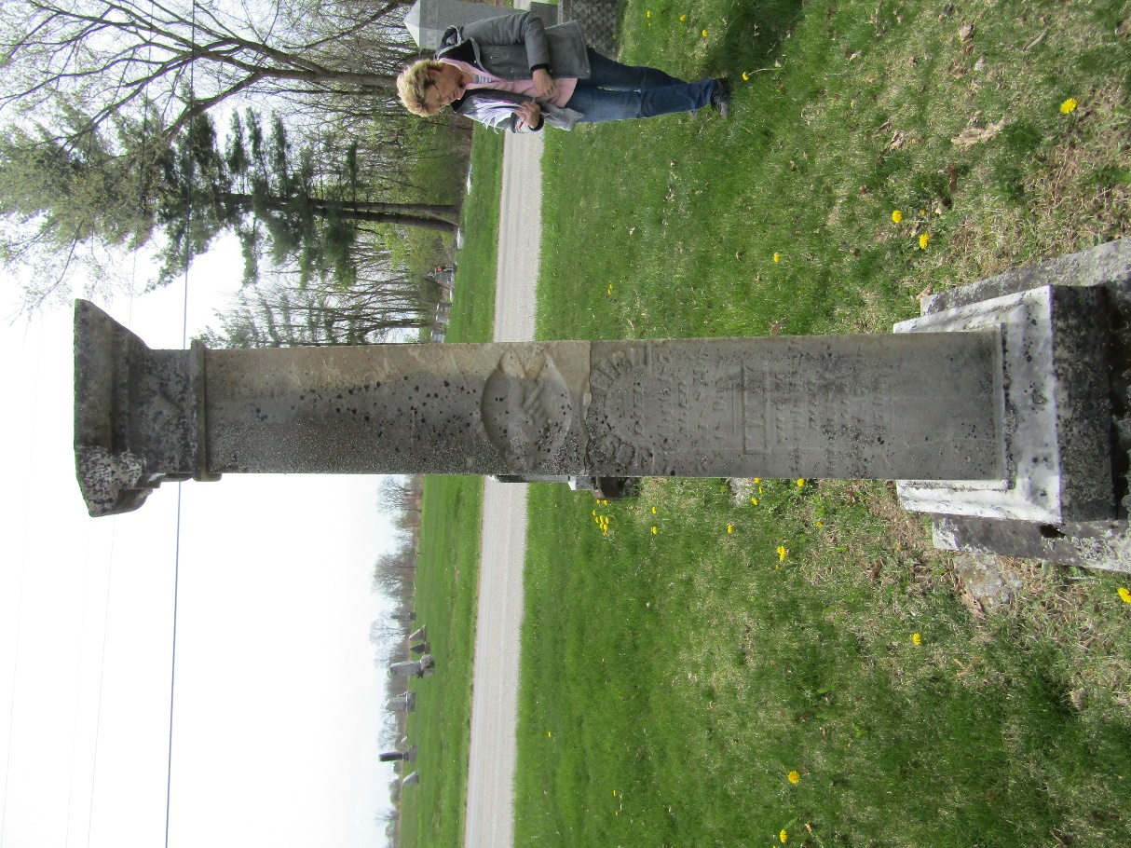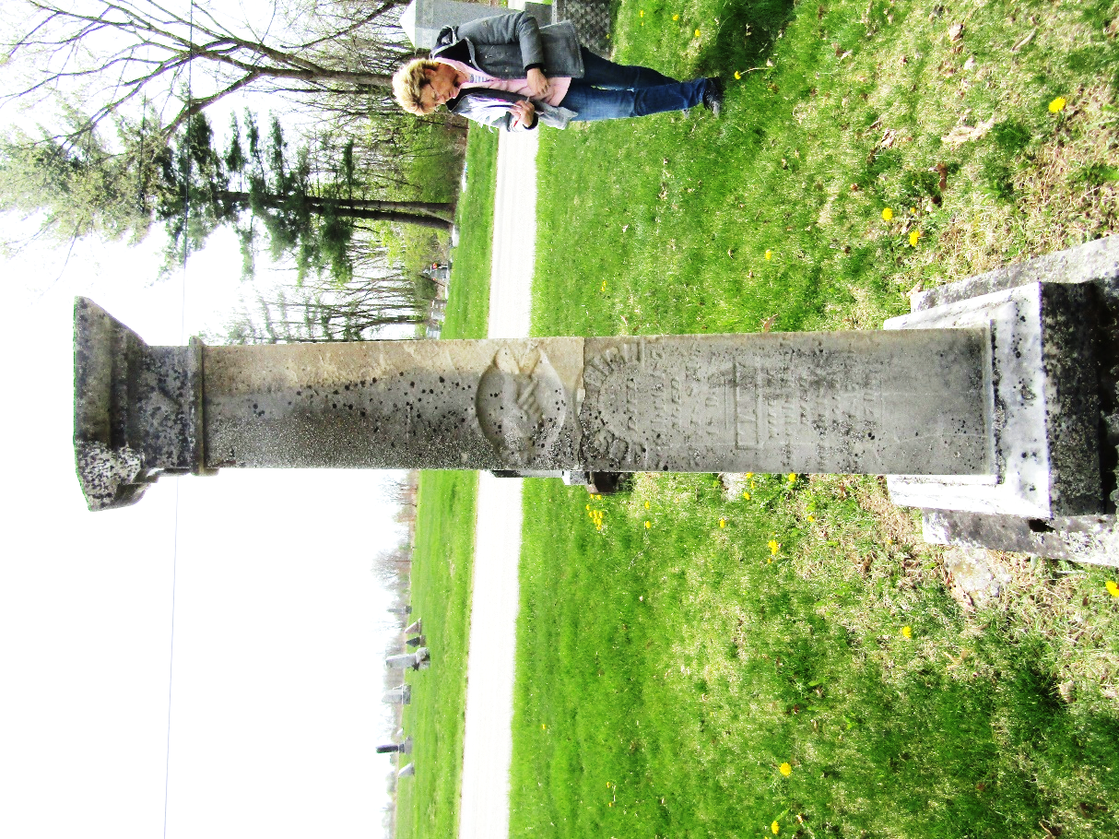

Joseph High from tree Filer-Woods Family
Birth 18 Dec 1794 Deerfield, Cumberland, New Jersey, USA
Marriage 1816 New Jersey, USA
Residence 1870 Bartholomew, Indiana, USA
Death 6 Sep 1874 Bluffton, Wells, Indiana, USA
Father Andrew (Andreas) High (Hoch) (1763-1849)
Mother Phoebe Loper (1771-1854)
Spouse Mary Elizabeth "Polly" Dare (1802-1891)

