John High
October 25, 1880 – May 10, 1886

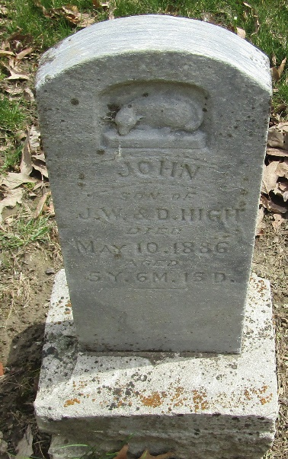

John High from tree Hoover010122
Birth 25 Oct 1880
Death 10 May 1886
Father Joseph William High (1859-1916)
Mother Adelia Spisey (Born 1860)

