Henry High
July 31, 1870 – September 27, 1901

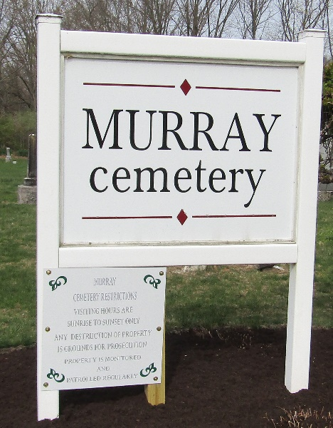

Henry High
in the Indiana, U.S., Death Certificates, 1899-2017
Name Henry High
Gender Male
Race White
Marital Status Married
Age 31 years, 1 month, 27 days
Birth Date abt 1870
Birth Place Indiana
Death Date 27 Sept 1901
Death Place Bluffton, Wells, Indiana, USA
Death Registration Date 1901
Father Ephram High
Mother Elizabeth Shady
Informant Family; Bluffton, Indiana
Burial September 27, 1901; Murray Cemetery

