Emily (Dailey) High
March 12, 1825 – February 3, 1866

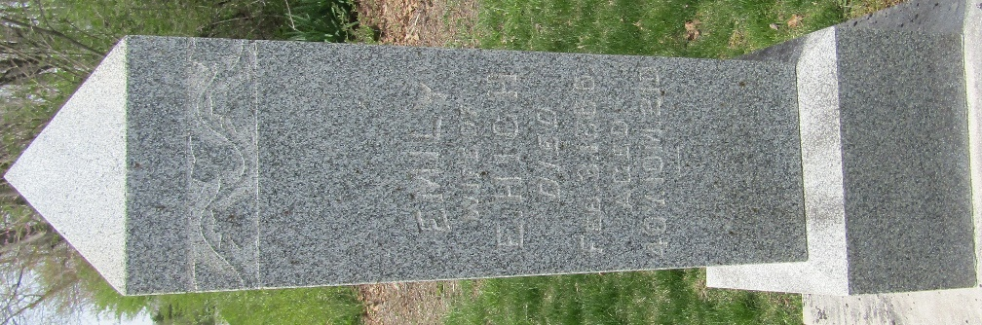

Emily Dailey from tree Partain/Guzman Family Tree
Birth 12 Mar 1825 New Jersey, USA
Marriage 6 Jan 1853 Wells, Indiana, USA
Residence 1860 Wells, Indiana, USA
Death 3 Feb 1866 Wells, Indiana, USA
Father James Dailey (1787-1849)
Mother Mary Ann Miller (1791-1840)
Spouse Ezekiel High (1820-1860)

