Elizabeth (Shady) High
March 12, 1833 – August 12, 1875

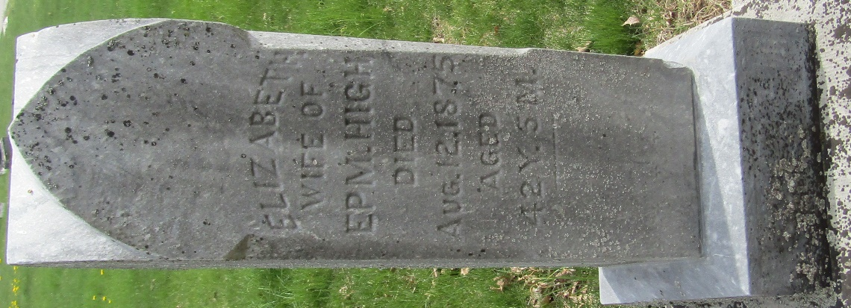

Elizabeth (Shady) High from tree Shady Family Tree
Birth 12 Mar 1833 Fairfield, Ohio, USA
Marriage 27 Dec 1856 Allen, Indiana, USA
Residence 1870 Wells, Indiana, USA
Death 12 Aug 1875 Wells, Indiana, USA
Father William Shady (1804-1879)
Mother Susanna A Grimm (1803-1876)
Spouse Ephraim High (1832-1904)

