Calvin T. High
October 6, 1866 – November 24, 1879

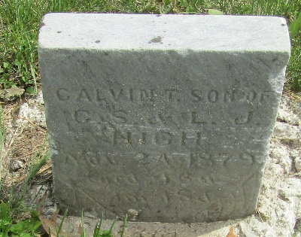

Calvin T High from tree Forbis-Jones Ancestor's Descendants
Birth 6 Oct 1866 Wells, Indiana, USA
Residence 1870 Wells, Indiana, USA
Death 24 Nov 1879 Wells, Indiana, USA
Father Charles S High (1830-1907)
Mother Lydia J Kleinknight (1833-1921)

