Alberta Marie (Waggoner) High
July 3, 1927 – October 21, 1996

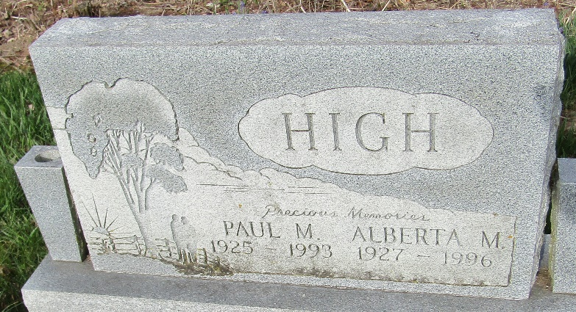

Alberta Marie High
in the Indiana, U.S., Death Certificates, 1899-2017
Name Alberta Marie High
[Alberta Marie Waggoner]
Gender Female
Race Caucasian (White)
Marital Status Widowed
Age 69
Birth Date 3 Jul 1927
Birth Place Fort Wayne, Indiana
Death Date 21 Oct 1996
Death Place Bluffton, Wells, Indiana, USA
Death Registration Date 1996
Father William M Waggoner
Mother Sadie F Parson
Informant Elaine Aeschliman; daughter; Auburn, Indiana
Burial October 23, 1996; Murray Cemetery; Murray, Indiana

