Julia J. (Richards) Hetrick
October 16, 1855 – September 21, 1942

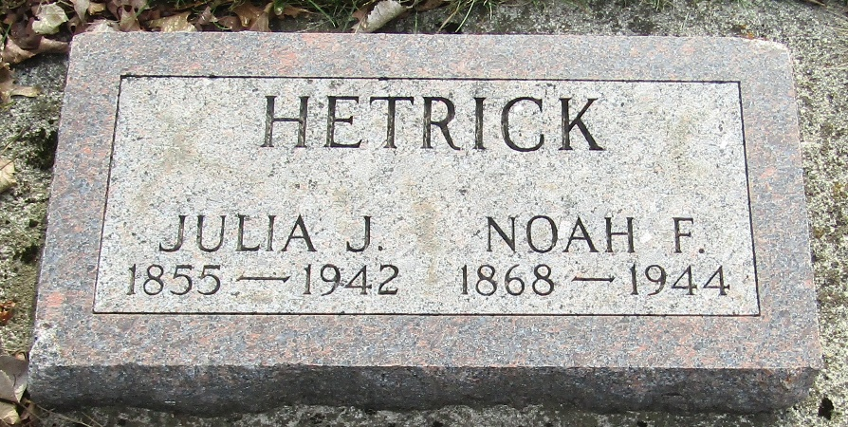

Julia J Hetrick
in the Indiana, U.S., Death Certificates, 1899-2017
Name Julia J Hetrick
[Julia J Ritchards]
Gender Female
Race White
Marital Status Married
Age 87
Birth Date 16 Oct 1854
Birth Place Holmes County, Ohio
Death Date 21 Sep 1942
Death Place Rural, Adams, Indiana, USA
Death Registration Date 1942
Father Thomas Ritchards
Mother Anna C Lash
Spouse Noah T Hetrick; age 74
Informant Noah Hetrick; Magley, Indiana
Burial September 23, 1942; Murray Cemetery; Lancaster Township, Indiana

