Tobias Henline
October 1, 1817 – October 23, 1876

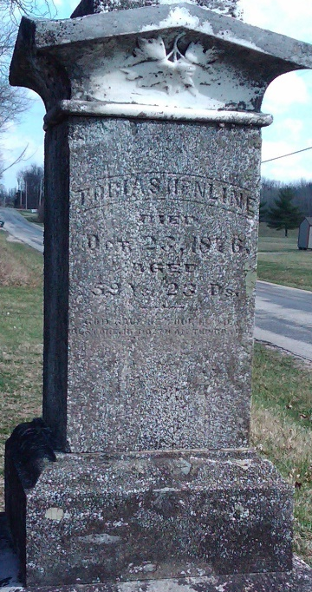
Photo by Shooter

Tobias Henline from tree Bechtel Family Tree
Birth 1 Oct 1817 Stark, Ohio, USA
Marriage 20 Oct 1857 Wells, Indiana, USA
Residence 1881 Canton, Stark, Ohio, USA
Death 23 Oct 1876 Wells, Indiana, USA
Father David H. Henline (Hanline) (1783-1855)
Mother Catherine Yerger (Jerger or Jager) (1786-1857)
Spouse Rebecca A. Kreigh (1830-1917

