Rebecca (Kreigh) Henline
October 7, 1830 – January 18, 1917

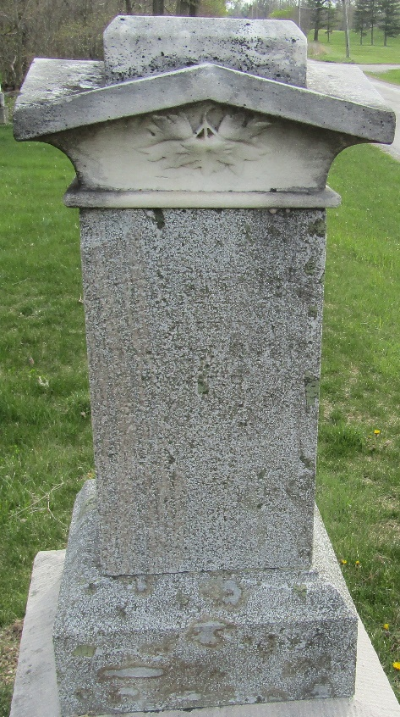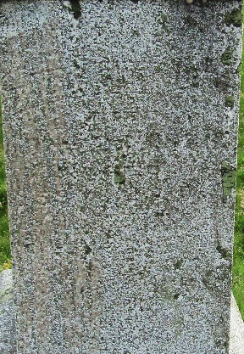

Rebecca Henline
in the Indiana, U.S., Death Certificates, 1899-2017

Name Rebecca Henline
[Rebecca Kreigh]
Gender Female
Race White
Marital Status Widowed
Age 86
Birth Date 7 Oct 1830
Birth Place Pennsylvania
Death Date 18 Jan 1917
Death Place Ossian, Wells, Indiana, USA
Death Registration Date 1917
Father Joseph Kreigh
Mother Mary E. Ressler
Spouse Tobias Henline
Informant Joe Henline; Ossian, Indiana
Burial January 20, 1917; Ossian, Indiana

