Mary E. Henline
1866 – March 12, 1870

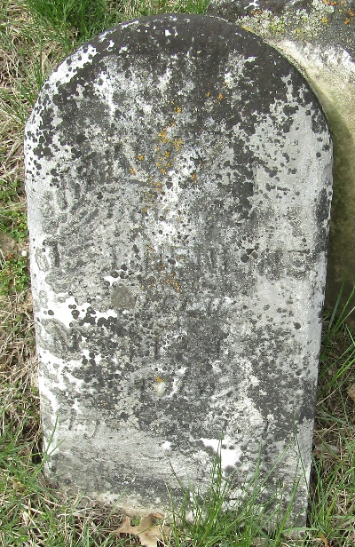

Mary E Henlein from tree Palmer St Clair Family Tree
Birth 1866 Wells, Indiana, USA
Residence 1880 Freedom, Wood, Ohio, USA
Death 12 Mar 1870 Wells, Indiana, USA
Father Tobias Henline (1836-1880)
Mother Helen A Henlein (Born 1845)

