George Washington Henline
January 31, 1867 – January 9, 1870

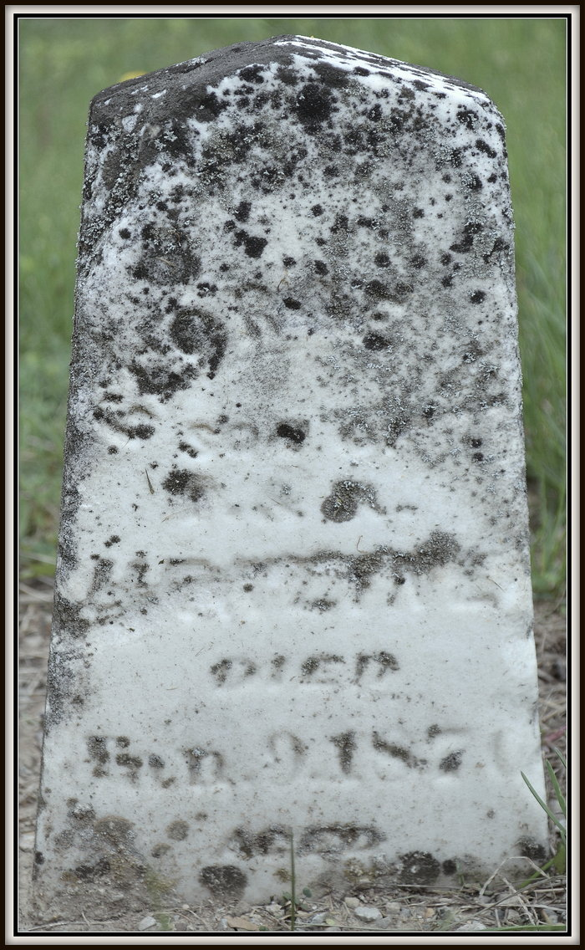
Photo by Shooter

George Washington Henline from tree Samuel Alan's Family Tree
Birth 31 Jan 1867 Wells, Indiana, USA
Death 9 Jan 1870 Wells, Indiana, USA
Father Tobias Henline (1817-1876)
Mother Rebecca A. Kreigh (1830-1917)

