David Clinton Henline
January 31, 1864 – January 23, 1943

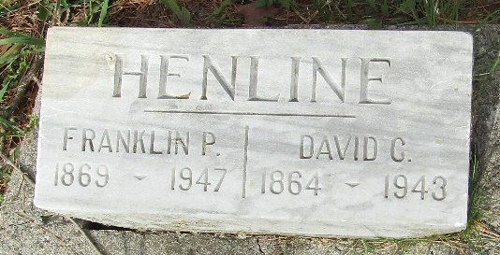

David Henline
in the Indiana, U.S., Death Certificates, 1899-2017
Name David Henline
Gender Male
Race White
Marital Status Single
Age 78
Birth Date 31 Jan 1864
Birth Place Wells County, Indiana
Death Date 23 Jan 1943
Death Place Rural, Wells, Indiana, USA
Death Registration Date 1943
Father Tobias Henline
Mother Rebecca Kreigh
Informant Martin Henline; Ossian, Indiana
Burial January 25, 1943; Murray Cemetery; Wells County, Indiana

