David Henline
June 1, 1783 – October 10, 1855

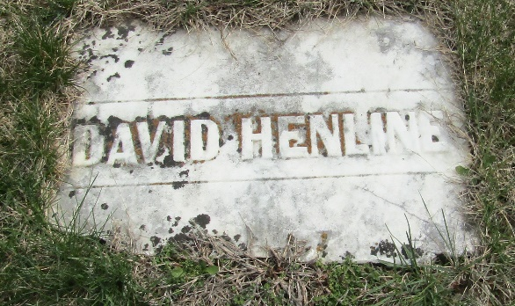

David Henline from tree Hineline family tree
Birth 1 Jun 1783 Franklin, Beaver, Pennsylvania, USA
Marriage 9 Feb 1806 Blair, Blair, Pennsylvania, USA
Residence 13 Sep 1850 Wells, Indiana, USA
Death 10 Oct 1855 Wells, Indiana, USA
Father Tobias Hanline (1754-1829)
Mother Elizabeth Miller (1757-1838)
Spouse Catherine Yarger (1786-1857)

