Catherine (Yerger) Henline
September 19, 1786 – August 8, 1857

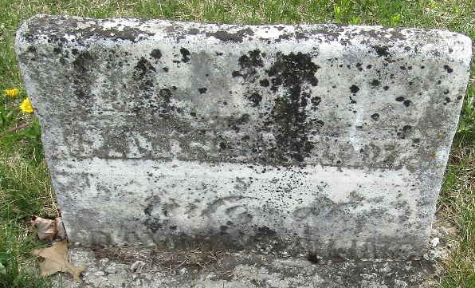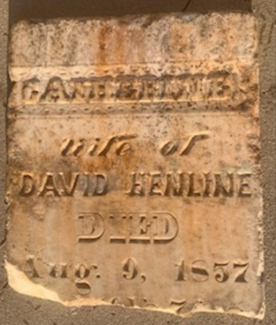

No further information found at this time

