Jefferson Monroe Helms
July 22, 1859 – December 18, 1906

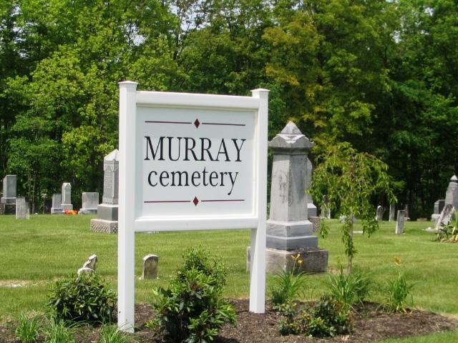
Photo by Barbara Baker Anderson

Jefferson Monroe Helner
in the Indiana, U.S., Death Certificates, 1899-2017
Name Jefferson Monroe Helms
Gender Male
Race White
Marital Status Married
Age 47
Birth Date 22 Jul 1859
Birth Place Wells County, Indiana
Death Date 18 Dec 1906
Death Place Bluffton, Wells, Indiana, USA
Death Registration Date 1906
Father Lenby? Helm
Mother Catherin Moyer
Spouse Anna
Informant Anna Helm; Bluffton, Indiana
Burial December 20, 1906; Murray Cemetery

