Garth F. Helms
September 1, 1903 – August 14, 1906

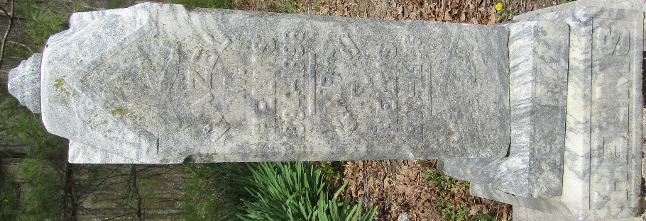

Garth Helms
in the Indiana, U.S., Death Certificates, 1899-2017
Name Garth Helms
Gender Male
Race White
Marital Status Single
Age 2
Birth Date 1 Sept 1903
Birth Place Wells County, Indiana
Death Date 14 Aug 1906
Death Place Lancaster, Wells, Indiana, USA
Death Registration Date 1906
Father J N Helms
Mother Anna Gilliand
Informant J. N. Helms; Bluffton, Indiana
Burial August 15, 1906; Murray Cemetery

