Anna M. (Gilliland) Helms-Bailey
August 8, 1869 – November 22, 1941

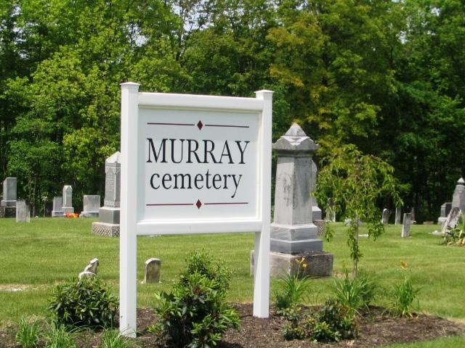
Photo by Barbara Baker Anderson

Anna M Helms Bailey
in the Indiana, U.S., Death Certificates, 1899-2017
Name Anna M Helms Bailey
[Anna M Helms Gilliland]
Gender Female
Race White
Marital Status Divorced
Age 72
Birth Date 8 Aug 1869
Birth Place Wells County, Indiana
Death Date 22 Nov 1941
Death Place Richmond, Wayne, Indiana, USA
Death Registration Date 1941
Father Henry Gilliland
Mother Sarah Trullender
Informant Hospital Records; Richmond, Indiana
Burial November 24, 1941; Fairview Cemetery; Bluffton, Indiana

**
Indiana, U.S., Marriage Index, 1800-1941
Name Anna Gillilend
Marriage Date 25 Dec 1889
Marriage Place Wells, Indiana, USA
Spouse Name Jefferson Helms

**
Indiana, U.S., Marriages, 1810-2001
Name Anna Helms
[Anna Gillilland]
Gender Female
Race White
Age 42
Event Type Marriage Registration (Marriage)
Birth Date 25 Aug 1869
Birth Place Wells, Indiana
Marriage Date 20 Mar 1912
Marriage Place Indiana, United States
Residence Place Bluffton, Indiana
Father Henry Gillilland
Mother Sarah Truellender
Spouse Charley Rowe
Page 232
FHL Film Number 002318675

**
U.S., Marriage Certificates, 1960-2012
Name Anna Gilliland
Gender Female
Race White
Birth Place Wells, Indiana
Marriage Date 20 Sep 1913
Marriage Place Wells, Indiana, USA
Residence Place Bluffton, Indiana
Spouse John Bailey

