William Presly Hege
April 10, 1851 – July 17, 1858

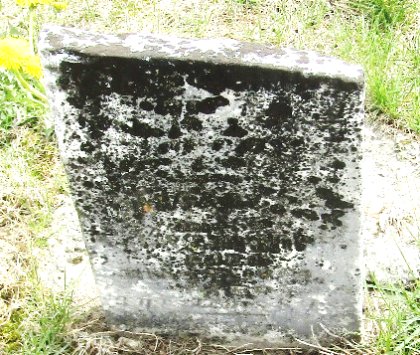

William Presly Hege from tree Ferguson Family Tree
Birth 10 Apr 1851 Indiana, USA
Death 17 Jul 1858 Wells, Indiana, USA
Father Christopher Hege (1819-1895)
Mother Martha Law (1816-1870)

