Ralph Hege
January 31, 1906 – April 26, 1943

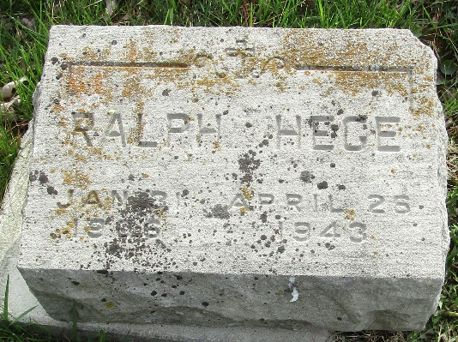

Ralph Heye
in the Indiana, U.S., Death Certificates, 1899-2017
Name Ralph Hege
Gender Male
Race White
Marital Status Married
Age 37
Birth Date 31 Jan 1906
Birth Place Fort Wayne, Allen, Indiana
Death Date 26 Apr 1943
Death Place Fort Wayne, Allen, Indiana, USA
Death Registration Date 1943
Father Charles Hege
Mother Clara Grotrian
Spouse Grace
Informant Grace Hege
Burial April 28, 1943; Murray Cemetery; Wells County, Indiana

