Mary Elizabeth (Patten) Hege
1847 – October 20, 1896

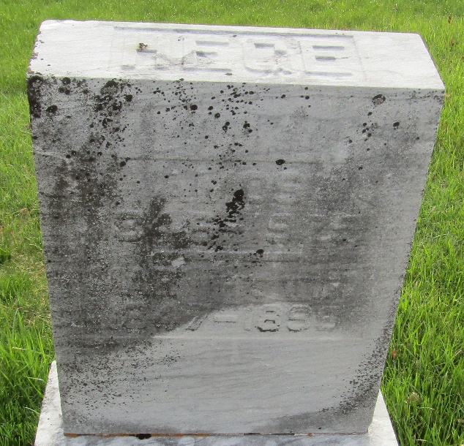

Mary Elizabeth Patten from tree Morecraft Family Tree
Birth 1847 Hamilton, Ohio, USA
Marriage 26 Sep 1870 Huntington, Cabell, West Virginia, USA
Residence 1883 Wells, Indiana, USA
Death 20 Oct 1896 Wells, Indiana, USA
Father David Patten (1818-1900)
Mother Elizabeth Crum (1820-1884)
Spouse Amos L. Hege (1846-1929)

