Glen Frank Hege
August 24, 1915 – July, 1982

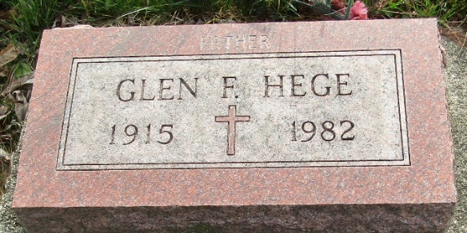

Glen Frank Hege
in the Indiana, U.S., Marriage Certificates, 1960-2012
Name Glen Frank Hege
Gender Male; Race White
Marriage Age 24
Birth Date 24 Aug 1915
Birth Place Fort Wayne, Allen, Indiana
Marriage License Date 9 Sep 1939
Marriage Date 9 Sep 1939
Marriage Place Allen, Indiana, USA
Residence Place Allen, Indiana
Father Charles Hege
Mother Clara Grolstion
Spouse Helen Marie Smith Miller
Other Person Dorothy Gardner
Officiator W Harvey Hughes
**

Glen F Hege from tree McDowell-Giant-Santerre-Hannan Family Tree
Birth 24 Aug 1915 Allen, Indiana, USA
Residence 1 Apr 1940 Fort Wayne, Allen, Indiana, USA
Death Jul 1982 Decatur, Adams, Indiana, USA
Father Charles A Hege (1873-1932)
Mother Clara I Grotrian (1884-1970)

