Frank Lawrence Hege
March 8, 1873 – March 30, 1949

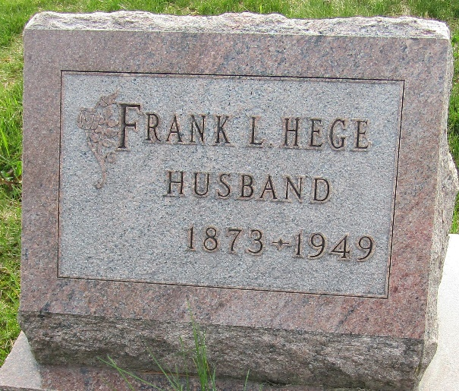

Frank Lawrence Hege
in the Indiana, U.S., Death Certificates, 1899-2017
Name Frank Lawrence Hege
Gender Male
Race White
Marital Status Married
Age 76
Birth Date 8 Mar 1873
Birth Place Ohio
Death Date 30 Mar 1949
Death Place Fort Wayne, Allen, Indiana, USA
Death Registration Date 1949
Father Amos Hege
Mother Elizabeth Patton
Informant Robert Hege; Fort Wayne, Indiana
Burial April 1, 1949; Murray Cemetery; Bluffton, Indiana

