Clara Marie (Grotrian) Hege-Dinger
August 18, 1884 – April 20, 1970

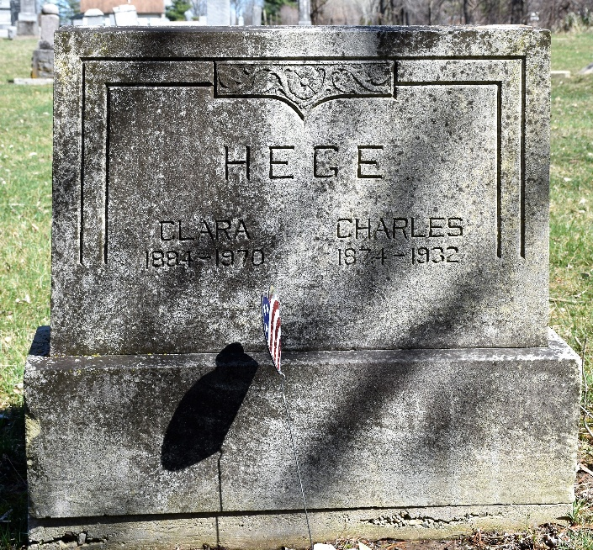
Photo by Colleen Sanders Broyles

Mrs. Clara Hege Dinger, 85, formerly of Fort Wayne, Route 7, died Monday at the home of her daughter, Mrs. LeRoy Emenhiser of Route 1, Monroe, Indiana.
Surviving are another daughter, five sons, 18 grandchildren and 9 great grandchildren.
Services will be held Thursday at the St. John’s Lutheran Church at Flat Rock; burial in the Murray Cemetery.

Bluffton News-Banner, Wells County, Indiana
April 20, 1970

**
Mrs. Clara Dinger Taken by Death

Mrs. Clara Hege Dinger, 85, formerly of Fort Wayne Route 7, died Monday morning at the home of a daughter, Mrs. Leroy Emenhiser, Monroe Route 1, with whom she had been residing. She had been ill about two months.
Mrs. Dinger was a member of St. John's Lutheran Church at Flat Rock.
Surviving are five sons, Carl, Roy, Wayne and Lawrence, all of Fort Wayne; and Glen Hege of Decatur; two daughters, Mrs. Emenhiser, and Mrs. Alvin Bearman of Fort Wayne; 18 grandchildren and nine great-grandchildren.
Funeral services will be held at 1:30 p.m. Thursday at St. John's Lutheran Church at Flat Rock, with Rev. Otto A. L. Mueller officiating. Burial will be in the Murray Cemetery in Wells County. Friends may call at the E. Harper & Son Funeral Home in New Haven after 7 p.m. today and at the church after 12:30 p.m. Thursday.

Decatur Daily Democrat, Adams County, Indiana
Tuesday, April 21, 1970
**
Indiana, U.S., Death Certificates, 1899-2017
Name Clara M Dinger
[Clara M Grotrian]
Gender Female
Race White
Marital Status Widowed
Age 85
Birth Date 18 Aug 1884
Birth Place Indiana
Death Date 20 Apr 1970
Death Place Monroeville, Allen, Indiana, USA
Death Registration Date 1970
Father Charles Grotrian
Mother Henrietta Gable
Informant Roy Hege; son; Fort Wayne, Indiana
Burial April 23, 1970; Murray Cemetery; Bluffton, Indiana

**
Indiana, U.S., Marriages, 1810-2001
Name Clara I Grotrian
Gender Female; Race White
Age 21
Birth Date 18 Aug 1884; Birth Place Madison Twp, Allen, Indiana
Marriage Date 24 Sep 1905;
Marriage Place Indiana, United States
Residence Place Madison Twp, Allen, Indiana
Father Charles Grotrian; Mother Henrietta Goble
Spouse Charles A Hege
Officiator W A Johnson
Page 208
**
Indiana, U.S., Marriage Certificates, 1960-2012
Name Clara Marie Hege
Gender Female
Race White
Marriage Age 65
Birth Date 18 Aug 1884; Birth Place Madison Twp
Marriage License Date 15 Nov 1949
Marriage Date 15 Nov 1949
Marriage Place Allen, Indiana, USA
Residence Place Fort Wayne
Spouse Robert Henry Dinger

