Charles A. Hege
December 23, 1873 – March 7, 1932

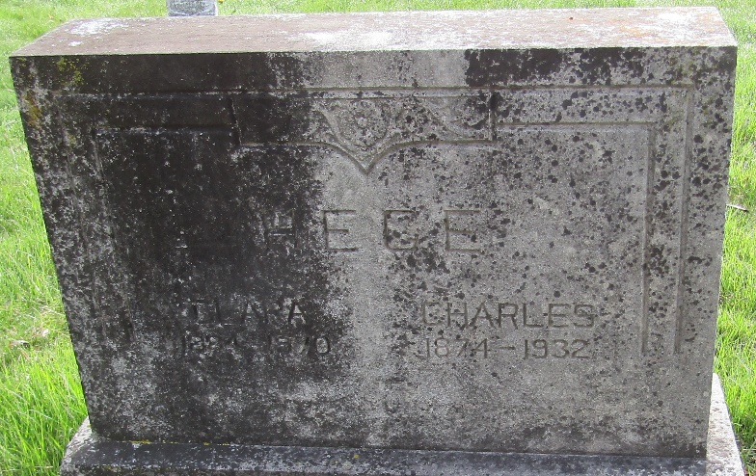

Charles A Hege
in the Indiana, U.S., Death Certificates, 1899-2017
Name Charles A Hege
Gender Male
Race White
Marital Status Married
Age 58
Birth Date 23 Dec 1873
Birth Place Wells County, Indiana
Death Date 7 Mar 1932
Death Place Fort Wayne, Allen, Indiana, USA
Death Registration Date 1932
Father Amriel Wells [sic]
Mother Mary E. Potton
Spouse Clara Winter
Informant Clara Hege
Burial March 10, 1932; Murray Cemetery

**
Indiana, U.S., Marriage Certificates, 1960-2012
Name Charles A Hege
Gender Male; Race White
Marriage Age 27
Birth Date 21 Dec 1877; Birth Place Huntington, Indiana
Marriage License Date 24 Sep 1905
Marriage Date 3 Sep 1905; Marriage Place Allen, Indiana, USA
Residence Place Fort Wayne, Indiana
Father Amos L Hege
Mother Mary E Patten
Spouse Clara I Grotrian
Other Person W A Johnson
Officiator C W Diedrich

