Amos Hege
May 29, 1846 – October 3, 1929

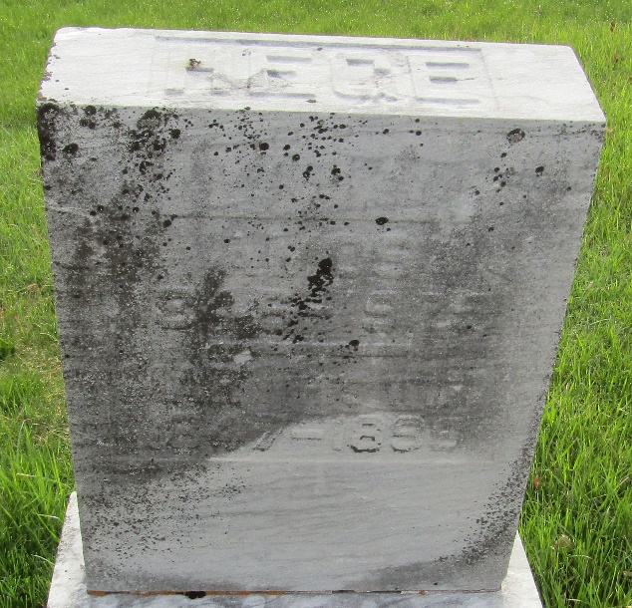

Amos Hege
in the Indiana, U.S., Death Certificates, 1899-2017
Name Amos Hege
Gender Male
Race White
Marital Status Widower
Age 83
Birth Date 29 May 1846
Birth Place Murray, Indiana
Death Date 3 Oct 1929
Death Place Murray, Wells, Indiana, USA
Death Registration Date 1929
Father John Hege
Mother Elizabeth Russel
Spouse Mary Patton
Informant Mrs. Chas. Harvey; Bluffton, Indiana
Burial Murray Cemetery

