Mary Hays
July 28, 1802 – July 26, 1863

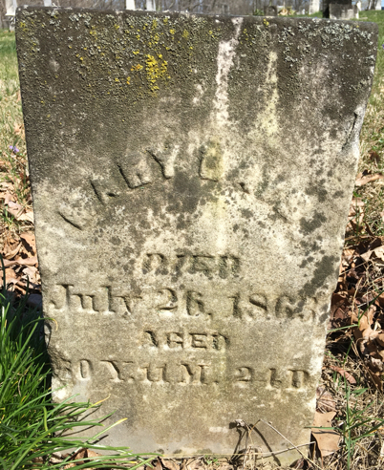

Mary Hays from tree Sharen Naico Family Tree
Birth 28 Jul 1802 Ohio, USA
Death 26 Jul 1863 Wells, Indiana, USA
Mother Leah Jane Morris (1786-1817)
Spouse John Hays (1795-1877)

