Sarah Ann (Donaldson) Hatfield
December 23, 1827 – March 24, 1880

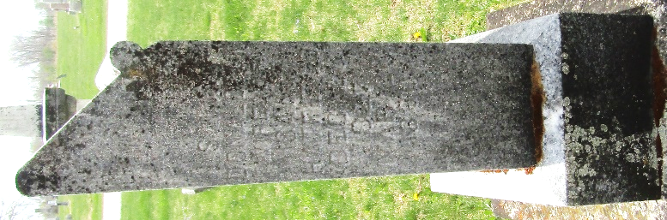

Sarah Ann Donaldson from tree Cottingim/Ainsworth/Vardaman/Mardis/Cobb
Birth 23 Dec 1827 Ligonier, Westmoreland, Pennsylvania, USA
Marriage 16 Feb 1858
Residence 1870 Wells, Indiana, USA
Death 24 Mar 1880 Ossian, Wells, Indiana, USA
Father Charles McClatchey Donaldson (1799-1880)
Mother Dorcas Felton (1800-1884)
Spouse James Hatfield (1832-1854)
Spouse Isaac Newton Hatfield (1818-1893)

