Phebe Peppard Hatfield
January 19, 1832 – November 17, 1872

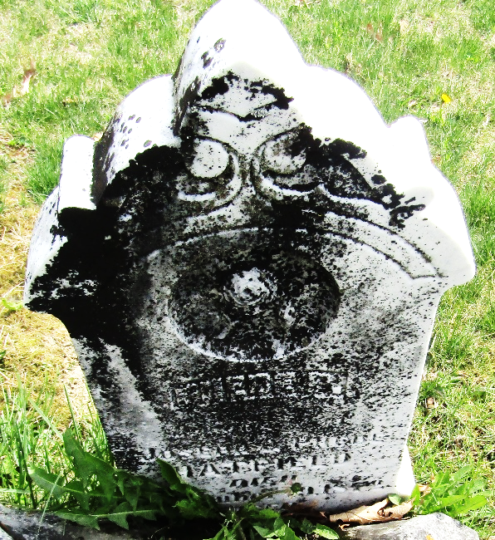

Phebe Peppard Hatfield from tree McLean Family Tree
Birth 18 Jan OR 19 Jan 1832 Union, Pike, Ohio, USA
Residence 1870 Ossian, Wells, Indiana, USA
Death 17 Nov 1872 Wells, Indiana, USA
Father Joseph Hatfield (1790-1875)
Mother Margaret Phoebe Peppard (1791-1832)
Spouse Robert Hatfield (1821-1901)

