Mary Ann (Marshall) Hatfield
September 30, 1798 – June 5, 1847

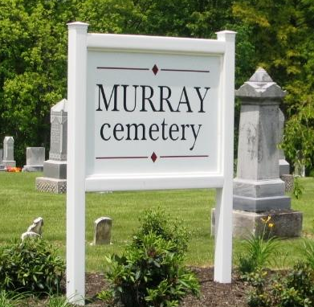
Photo by Barbara Baker Anderson

Mary Ann Marshall from tree Janshego
Birth 20 August 1798 OR 30 Sep 1798 Pennsylvania, USA
Marriage 24 Mar 1835 Wayne, Monroe, Ohio, USA
Death 5 Jun 1847 Wells, Indiana, USA
Father Robert Marshall (1769-1853)
Mother Agnes R Robinson (1769-1846)
Spouse Joseph Hatfield (1790-1875)

