Martha (Kirkpatrick) Hatfield
August 16, 1793 – August 20, 1840

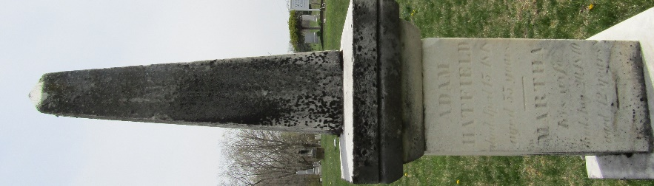

Martha Kirkpatrick from tree Matthew Wilson family tree
Birth 16 Aug 1793 OR 1798 Fayette City, Fayette, Pennsylvania, USA
Marriage 7 Nov 1820 Wayne, Monroe, Ohio, USA
Residence 1840 Jamestown, Boone, Indiana, USA
Death 20 Aug 1840 Wells, Indiana, USA
Father Daniel Kirkpatrick (1760-1821)
Mother Sarah Johnston (1765-1835)
Spouse Adam Hatfield (1793-1848)

