Martha Ann (Egbert) Hatfield
October 6, 1822 – July 9, 1852

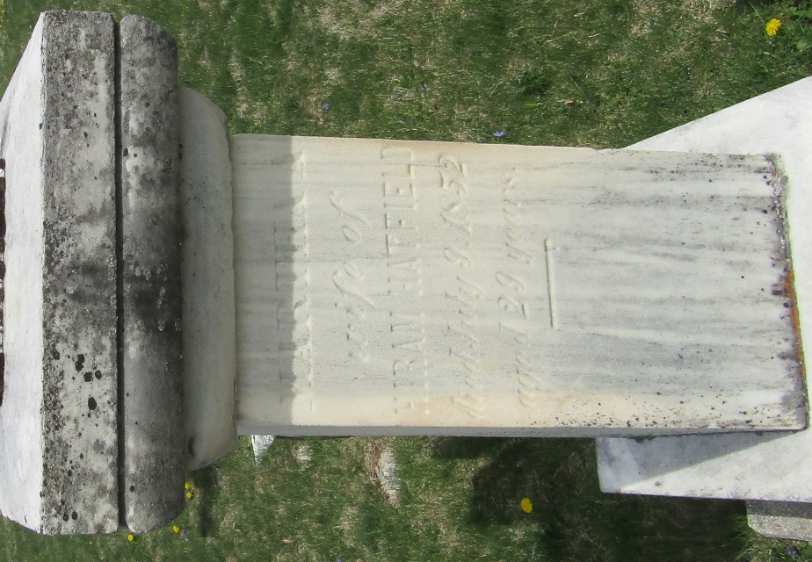

Martha Ann Egbert from tree Claffey
Birth 6 Oct 1822 Pennsylvania, USA
Marriage 6 May 1850 Wells, York, Maine, USA
Residence 1850 Wells, Indiana, USA
Death 9 Jul 1852
Father James Egbert (1782-1827)
Mother Rachael McMurran (1782-1833)
Spouse Hiram Hatfield (1827-1893)

