Joseph Hatfield
June 22, 1790 – July 6, 1875

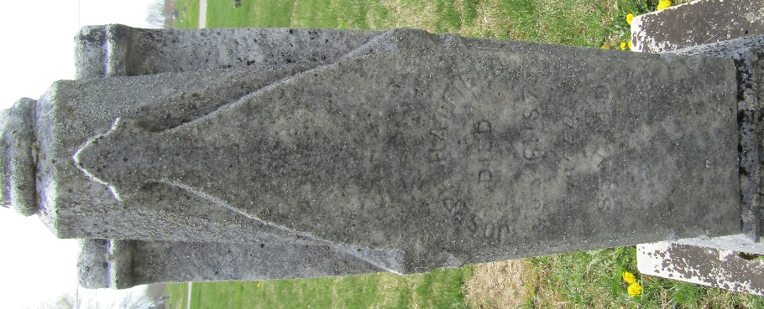

Joseph Hatfield from tree Hatfield - Sanders Family Tree
Birth 22 Jun 1790 Bullskin, Fayette, Pennsylvania, USA
Marriage 24 Mar 1835 Wayne, Monroe, Ohio, USA
Residence 1870 Wells, Indiana, USA
Death 6 Jul 1875 Ossian, Wells, Indiana, USA
Father Adam Hatfield (1741-1795)
Mother Margaret Dilworth (1750-1821)
Spouse Margaret Phoebe Peppard (1791-1832)
Spouse Mary Ann Marshall (1798-1847)
Spouse Freda Holfield
Spouse Margaret Glass (Born 1820)

