Isaac Hatfield
July 14, 1818 – October 3, 1898

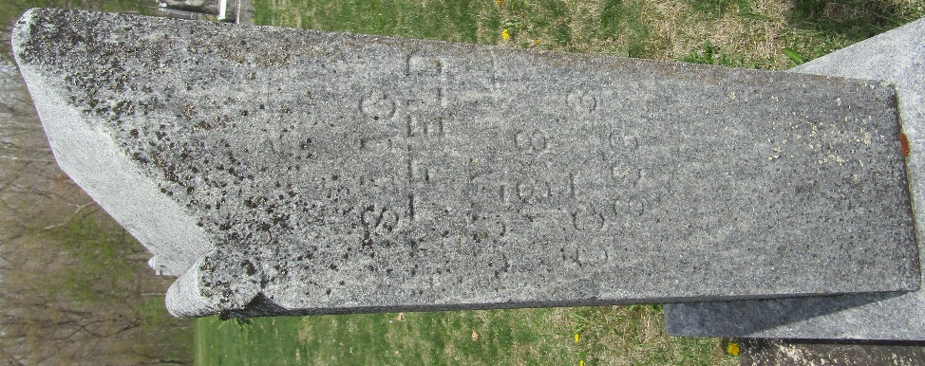

Isaac Hatfield from tree Dunbebin Family Tree
Birth 14 Jul 1818 Wells, Indiana, USA
Death 3 Oct 1898 Wells, Indiana, USA
Mother Mary Ann Hatfield (1798-1847)

