Frank Hatfield
September 30, 1877 – September 30, 1877

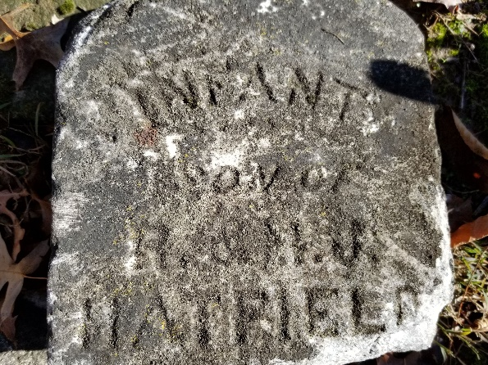

Frank Hatfield from tree pappline
Birth 30 Sep 1877 Wells, Indiana, USA
Death 30 Sep 1877 Wells, Indiana, USA
Father Robison Hatfield (1838-1907)
Mother Martha Jane Wilson (1841-1929)

