Charles Dilworth Hatfield
January 19, 1859 – May 21, 1860

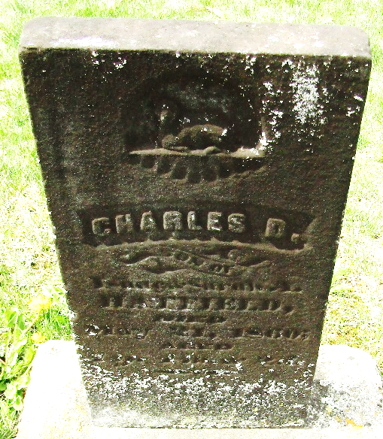

Charles Dilworth Hatfield from tree Gail Carolyn Schrader
Birth 19 Jan 1859 Wells, Indiana, USA
Death 21 May 1860 Wells, Indiana, USA
Father Isaac Newton Hatfield (1818-1893)
Mother Sarah Ann Donaldson (1827-1880)
4676 People 1 Record 4 Sources

