Adam Hatfield
March 3, 1793 – April 15, 1848

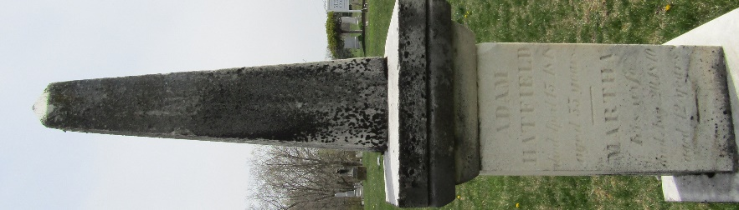

Adam Hatfield from tree Matthew Wilson family tree
Birth 3 Mar 1793 Bullskin, Fayette, Pennsylvania, USA
Residence 1840 Jamestown, Boone, Indiana, USA
Marriage 22 Jun 1843 Wells, Indiana, USA
Death 15 Apr 1848 Wells, Indiana, USA
Father Adam Hatfield (1763-1795)
Mother Margaret Dilworth (1750-1821)
Spouse Elizabeth Stewart (1800-1883)

