Sarah (Davis) Harvey
October 11, 1811 – July 5, 1887

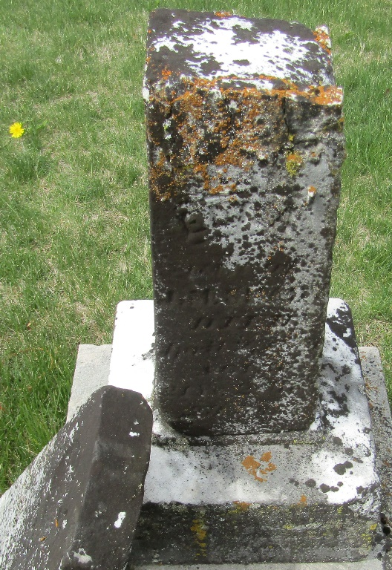

Sarah Davis from tree Theresa's Family Tree

Birth 11 Oct 1811 Greene, Tennessee, USA
Marriage 22 Aug 1850 Wells, Indiana, USA
Residence 1880 Wells, Indiana, USA
Death 5 Jul 1887 Wells, Indiana, USA
Father George W Davis (1782-1865)
Mother Susan C Miller (Born 1792)
Spouse James Harvey (1791-1843)
Spouse David Aker (1811-1888)

