Robert Harvey
February 29, 1788 – August 14, 1853

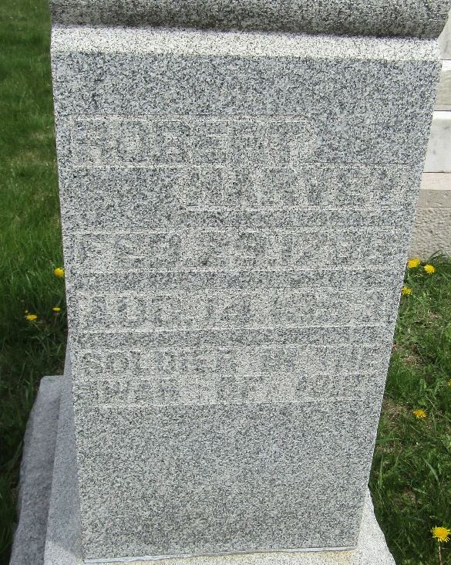

Robert Harvey from tree Cindy Gardner Family Tree

Birth 29 Feb 1788 Fannett, Franklin, Pennsylvania, USA
Marriage 19 Mar 1818 Ohio, USA
Residence 1850 Wells, Indiana, USA
Death 14 Aug 1853 Wells, Indiana, USA
Father Henderson Harvey (1755-1822)
Mother Martha McConnell (1760-1820)
Spouse Elizabeth Richey (1794-1878)

