Jeanetta (Gardiner) Harvey
September 5, 1830 – July 23, 1853

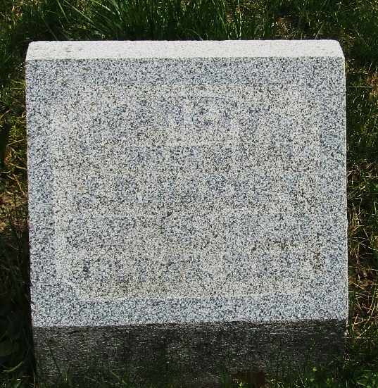

Jenette Gardiner from tree McCune/Jones Family Tree
Birth 5 Sep 1830 Ohio, USA
Residence 1 Jun 1850 Wells, Indiana, USA
Marriage 24 Mar 1853 Wells, Indiana, USA
Death 23 Jul 1853
Father James Gardiner (1799-1867)
Mother Jane McCaughey (1805-1863)
Spouse Jacob Harvey (1830-1904)

