James Harvey
1791 – August 8, 1843

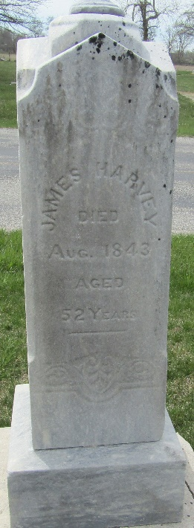

James Harvey from tree Smith Family Tree
Birth 1791 Fannett, Franklin, Pennsylvania, USA
Marriage 2 Oct 1831 Union, Indiana, USA
Residence 1840 Jefferson, Preble, Ohio, USA
Death 8 Aug 1843 Wells, Indiana, USA
Father Henderson Harvey (1755-1822)
Mother Martha Jane McConnell (1760-1820)
Spouse Sarah Davis (1811-1887)

