Jacob R. Harvey
April 27, 1830 – April 22, 1904

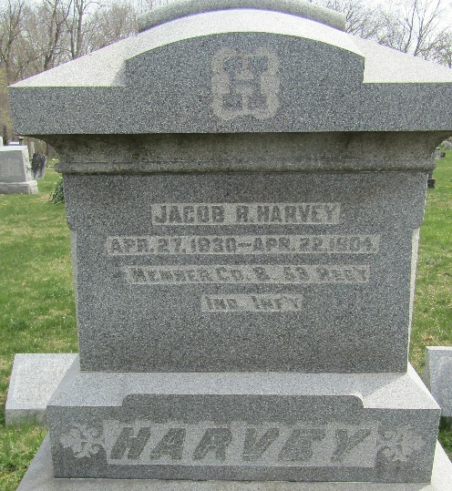

Jacob R Harrey
in the Indiana, U.S., Death Certificates, 1899-2017
Name Jacob R Harvey
Gender Male
Race White
Marital Status Widowed
Age 73
Birth Date 27 Apr 1830
Birth Place Indiana
Death Date 22 Apr 1904
Death Place Lancaster, Wells, Indiana, USA
Death Registration Date 1904
Father Robert Harvey
Mother Elizabeth Richey
Spouse Elizabeth Miller
Informant Robert Harvey; Bluffton, Indiana
Burial April 24, 1904; Murray Cemetery

