Harry W. Harvey
October 10, 1895 – August 7, 1964

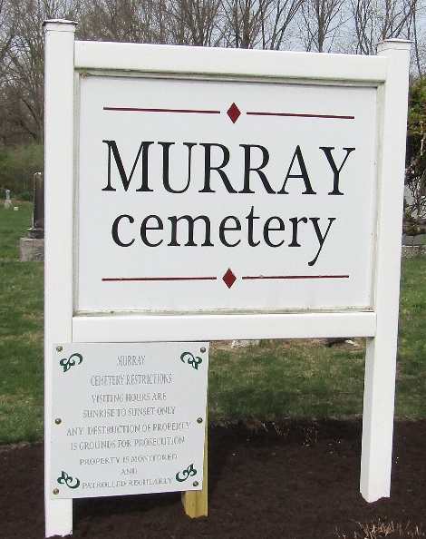

Rites Tuesday for Harry Harvey, 68

Services will be held Tuesday morning at the C.M. Sloan & Sons Funeral Home in Fort Wayne for Harry W. Harvey, 68, of Fort Wayne, who died at 10:35 pm Friday.
A native of Wells County, Mr. Harvey was a member of the Murray Christian Church. He had resided in Fort Wayne the last 22 years.
Surviving is the wife, the former Grace Smith; one daughter, Mrs. Elvira Tracy of Fort Wayne; one son, Charles T. of Miami, Florida and four grandchildren.
Burial will be in the Murray Cemetery.

Bluffton News-Banner, Wells County, Indiana
August 10, 1964

**
Indiana, U.S., Death Certificates, 1899-2017
Name Harry W Harvey
Gender Male
Race White
Marital Status Married
Age 68
Birth Date 10 Oct 1895
Birth Place Wells County, Indiana
Death Date 7 Aug 1964
Death Place Fort Wayne, Allen, Indiana, USA
Death Registration Date 1964
Father Charles E Harvey
Mother Arrilla M Hege
Informant Grace M Harvey; wife; Fort Wayne, Indiana
Burial August 11, 1964; Murray Cemetery; Murray, Indiana

