Elizabeth (Richey) Harvey
March 15, 1794 – July 12, 1878

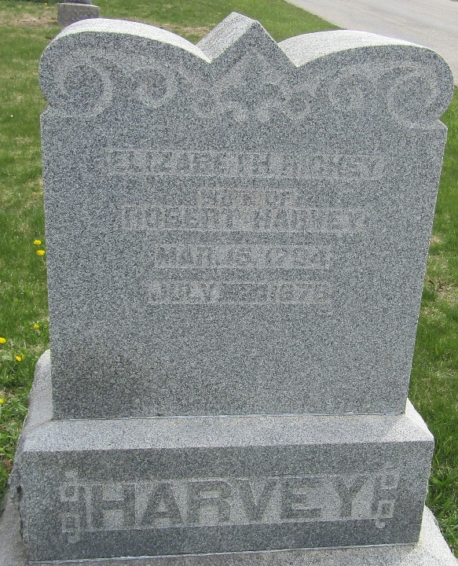

Elizabeth Richey from tree Cindy Gardner Family Tree
Birth 15 Mar 1794 New Jersey, USA
Marriage 19 Mar 1818 Butler, Montgomery, Ohio, USA
Residence 1870 Union, Indiana, USA
Death 12 Jul 1878 Wells, Indiana, USA
Father Jacob Richey (1770-1834)
Mother Mary Snethen (1773-1850)
Spouse Robert Harvey (1788-1853)

