Elizabeth (Miller) Harvey
March 15, 1834 – November 10, 1898

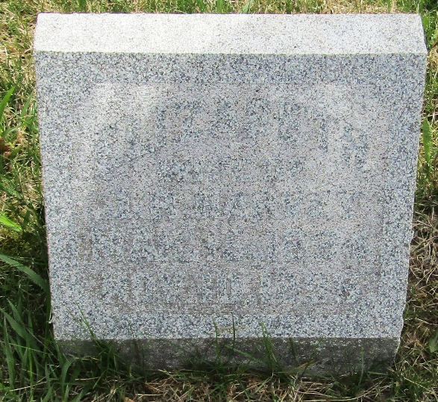

Elizabeth Miller from tree McCormack/Cox Family Tree
Birth 15 Mar 1834 Wells, Indiana, USA
Marriage 20 Sep 1855 Wells, Indiana, USA
Residence 1880 Wells, Indiana, USA
Death 10 Nov 1898 Wells, Indiana, USA
Father Henry Miller (1802-1882)
Mother Catherine "Caty" Seek (1801-1877)
Spouse Jacob Richey Harvey (1830-1904)

