Charles E. Harvey
November 5, 1871 – January 2, 1932

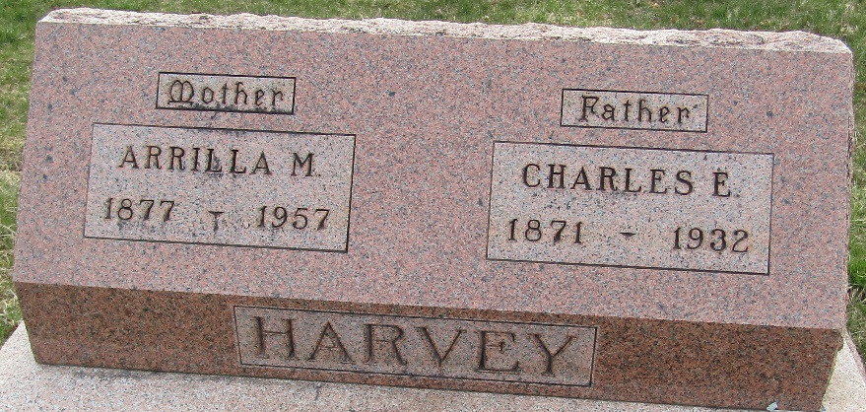

Charles E. Harvey
in the Indiana, U.S., Death Certificates, 1899-2017
Name Charles E. Harvey
Gender Male
Race White
Marital Status Married
Age 60
Birth Date 5 Nov 1871
Birth Place Lancaster Tp., Wells Co., Indiana
Death Date 2 Jan 1932; accidental gun shot
Death Place Lancaster Tp., Wells, Indiana, USA
Death Registration Date 1932
Father Jacob R. Harvey
Mother Elizabeth Miller
Spouse Arilla Hege
Informant None listed
Burial January 4, 1932; Murray Cemetery

