Arrilla M. (Hedge) Harvey
February 21, 1877 – February 18, 1957

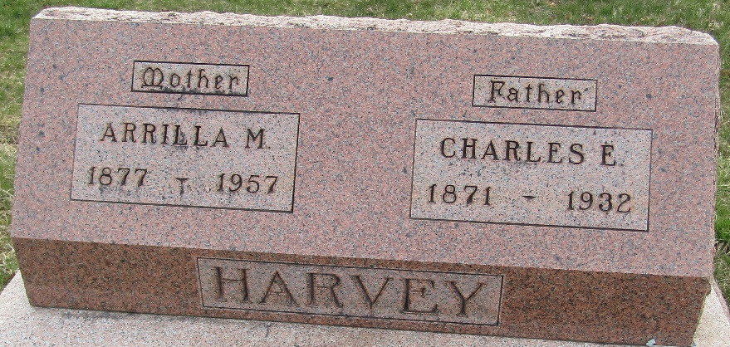

Arilla Harvey
in the Indiana, U.S., Death Certificates, 1899-2017
Name Arilla Harvey
[Arilla Hedge]
Gender Female
Race White
Marital Status Widowed
Age 78
Birth Date 21 Feb 1878 (sic)
Birth Place Indiana
Death Date 18 Feb 1957
Death Place Murray, Wells, Indiana, USA
Death Registration Date 1957
Father Amos Hedge
Mother Mary Patton
Informant Hospital records
Burial February 20, 1957; Murray Cemetery; Wells County, Indiana

