Elizabeth (Zeek) Hart
1801 – April 8, 1856

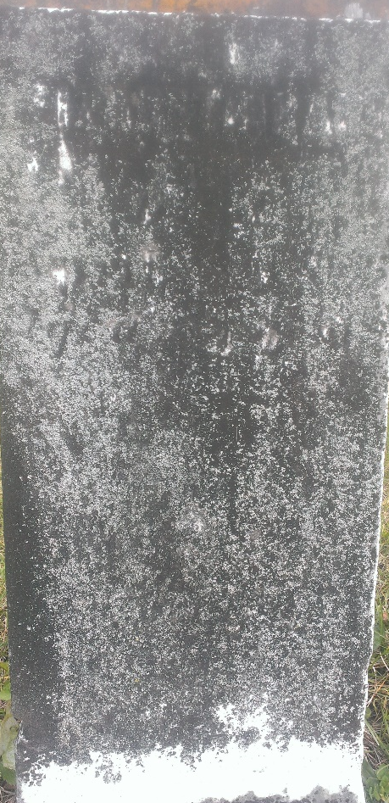

Elizabeth Seek from tree Garnier-Truman Extended Family
Birth 1801 Wythe, Virginia, USA
Marriage 4 Oct 1821 Wythe, Virginia, USA
Death 8 Apr 1856 Wells, Indiana, USA
Father Johann Adam Zeek (1773-1847)
Mother Mary Shaffer (1785-1842)
Spouse Benjamin A Hart (1801-1892)

