William Hanna
January 23, 1817 – April 6, 1873

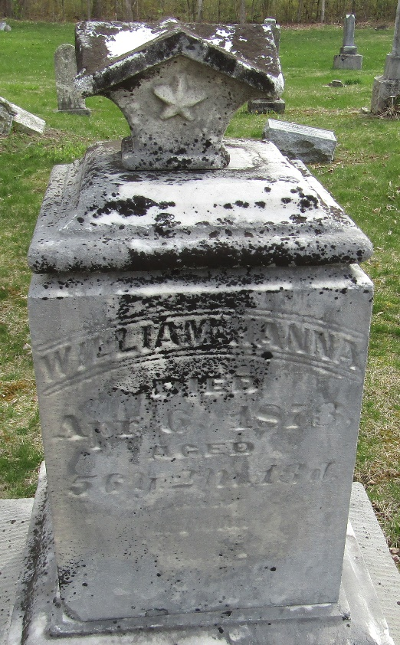

William Hanna from tree Reverend Archibald Hanna
Birth 23 Jan 1817 Dalton, Wayne, Ohio, USA
Marriage 25 Nov 1845 Wells, Indiana, USA
Residence 1870 Wells, Indiana, USA
Death 6 Apr 1873
Father Archibald ' Arch ' Hanna Hannah (1790-1875)
Mother Mary Ramage ( Hanna (1796-1859)
Spouse Eliza Caroline Riddle ( Hanna (1817-1876)

