Thomas Allen Hanna
December 3, 1848 – September 3, 1903

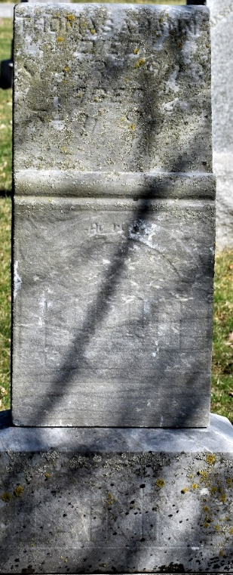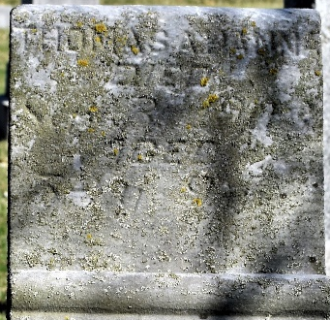

Mr. Thomas A. Hanna, the well-known proprietor of the Kingsland hotel, died at his home on the morning of September 3rd at the age of 54 years, 9 months. The deceased was born in Wells County, Indiana, December 3rd, 1848, and in 1873 was united in marriage to Miss Emma I. Benedict. To this union were born three children, two of whom survive him. He united with the Presbyterian church at the age of twenty-seven, and has lived a consistent, earnest and faithful christian life ever since.
Besides his wife and two children, there are left to mourn his loss an aged mother, Mrs. Maggie Black, of Chicago, and Mrs. Martha Merriman, of Bentonville, Ark. and a host of other relatives and friends.
Funeral services were conducted at the home on Friday afternoon and a large number of his friends gathered to pay the last tribute of respect to their departed friend. The remains were laid to rest in the cemetery at Murray.

Unknown source

**
Thomas Allen Hanna
in the Indiana, U.S., Death Certificates, 1899-2017

Name Thomas Allen Hanna
Gender Male
Race White
Marital Status Married
Age 54
Birth Date 3 Dec 1848
Birth Place Pennsylvania
Death Date 3 Sep 1903
Death Place Kingsland, Wells, Indiana, USA
Death Registration Date 1903
Father Daniel Hanna
Mother Nancy Law
Spouse Emma
Informant Emma Hanna; Kingsland, Indiana
Burial September 4, 1903; Murray, Indiana

